编号： ______________
版本： ________________

Project：系统调用

编写: 冯嘉程 2012年5 月4 日

小组成员
冯嘉程、杨金礼、张晓雷、丹增顿云

实验目的与总体结构

2.1、实验目的
了解操作系统系统调用

2.2、实验描述
在系统中真正被所有进程都使用的内核通信方式是系统调用。例如当进程请求内核服务时，就使用的是系统调用。一般情况下，进程是不能够存取系统内核的。它不能存取内核使用的内存段，也不能调用内核函数，CPU的硬件结构保证了这一点。只有系统调用是一个例外。进程使用寄存器中适当的值跳转到内核中事先定义好的代码中执行，（当然，这些代码是只读的）。
本实验就是在一个已有的系统调用的框架上完善几个系统调用，主要包括ipc和fork。

实验内容

3.1、/user/syscall_warp.s

3.1.1、实验步骤
需要实现的几个函数：
1）static void *alloc(u_int n, u_int align, int clear)：分配一个n大小的空间，返回一个指向这个空间的指针，按照align大小对齐，同时如果clear为1，将这个空间清0。
2）static Pte* boot_pgdir_walk(Pde *pgdir, u_long va, int create)：用虚拟地址va查找页目录，如果对应的页目录项已分配，则返回指向va对应页表项的指针；否则，分配新的页面，将它的首地址放入对应的页目录项，返回指向va对应页表项的指针。
3）static void boot_map_segment(Pde *pgdir, u_long va, u_long size, u_long pa, int perm)：完成虚拟地址[va, va+size]到物理地址[pa,pa+size]的映射(填充对应的页表项)。
4）void mips_vm_init(void)：添加一些代码，完成初始化页目录，初始化将要用到的内存空间对应的一些页表(内核栈、物理内存、Page、Env等)。你的任务是按照指明的设计补充那空出来的代码。其它的一些函数对你会有一定的帮助。一旦你完成了这部分，运行代码，创建check_boot_pgdir()函数检查你所建立的页表机制并打印任何有可能的错误, 增加你自己的assert（）去判断你自己的假设实际上是否正确。在通过这个检查之前不要继续往下作。

3.1.2、实现方法
#include <asm/regdef.h>
#include <asm/cp0regdef.h>
#include <asm/asm.h>

LEAF(msyscall)

/////////////////////////////////////////
//insert your code here
//put the paramemters to the right pos
//and then call the "syscall" instruction
/////////////////////////////////////////
//fmars:
//j fmars
move v0,a0
sw a0,0(sp)
sw a1,4(sp)
sw a2,8(sp)
sw a3,12(sp)
syscall

jr ra

END(msyscall)

//move a0->v0
//move a1-3 to stack

3.2、/lib/syscall_all.c

3.2.1、实验步骤
这个文件共有 9 个系统调用函数需要我来实现：
- （1）int sys_set_pgfault_handler(int sysno, u_int envid, u_int func, u_int xstacktop)
- （2）int sys_mem_alloc(int sysno, u_int envid, u_int va, u_int perm)
- （3） int sys_mem_map(int sysno, u_int srcid, u_int srcva, u_int dstid,
- （4） sys_mem_unmap(int sysno, u_int envid, u_int va)
- （5） int sys_env_alloc(void)
- （6） int sys_set_env_status(int sysno, u_int envid, u_int status)
- （7）sys_set_trapframe(int sysno, u_int envid, struct Trapframe *tf)
- （8）void sys_ipc_recv(int sysno, u_int dstva)
- （9） int sys_ipc_can_send(int sysno, u_int envid, u_int value, u_int srcva,u_int perm)
。

3.2.2、实现方法
#include "../drivers/gxconsole/dev_cons.h"
#include <mmu.h>
#include <env.h>
#include <printf.h>
#include <pmap.h>

extern char * KERNEL_SP;
extern struct Env * curenv;

void sys_putchar(int sysno,int c,int a2,int a3,int a4,int a5)
{
printcharc((char) c);
return ;
}

void * memcpy(void *destaddr,void const *srcaddr,u_int len)
{
char *dest = destaddr;
char const *src = srcaddr;

while(len-->0)
*dest++=*src++;
return destaddr;
}

// return the current environment id
u_int sys_getenvid(void)
{
return curenv->env_id;
}

// deschedule current environment
void sys_yield(void)
{
bcopy((int)KERNEL_SP-sizeof(struct Trapframe),TIMESTACK-sizeof(struct Trapframe),sizeof(struct Trapframe));
sched_yield();
}

// destroy the current environment
void sys_env_destroy(int sysno,u_int envid)
{
/*
printf("[%08x] exiting gracefully\n", curenv->env_id);
env_destroy(curenv);
*/
int r;
struct Env *e;

if ((r=envid2env(envid, &e, 1)) < 0)
return r;
printf("[%08x] destroying %08x\n", curenv->env_id, e->env_id);
env_destroy(e);
return 0;
}

// Set envid's pagefault handler entry point and exception stack.
// (xstacktop points one byte past exception stack).
//
// Returns 0 on success, < 0 on error.
int sys_set_pgfault_handler(int sysno,u_int envid, u_int func, u_int xstacktop)
{
///////////////////////////////////////////////////////
//your code here
struct Env *e;
if( envid2env(envid, &e, 1) < 0)
panic("sys_set_pgfault_handler not implemented");
//printf("set pgfault handler\n");
e->env_pgfault_handler = func;
xstacktop = TRUP(xstacktop);
e->env_xstacktop = xstacktop;
return 0;
//
///////////////////////////////////////////////////////

}

//
// Allocate a page of memory and map it at 'va' with permission
// 'perm' in the address space of 'envid'.
//
// If a page is already mapped at 'va', that page is unmapped as a
// side-effect.
//
// perm -- PTE_U|PTE_P are required,
// PTE_AVAIL|PTE_W are optional,
// but no other bits are allowed (return -E_INVAL)
//
// Return 0 on success, < 0 on error
// - va must be < UTOP
// - env may modify its own address space or the address space of its children
//
int sys_mem_alloc(int sysno,u_int envid, u_int va, u_int perm)
{
///////////////////////////////////////////////////////
//your code here
struct Env *e;
struct Page *p;
if(envid2env(envid, &e, 1) < 0)
//panic("sys_mem_alloc not implemented");
return -1;
if(page_alloc(&p) < 0)
//panic("sys_mem_alloc not implemented");
return -1;
//if(!(perm & PTE_U) || !(perm & PTE_P))
// panic("sys_mem_alloc not implemented");
//memset(page2kva(p), 0 ,BY2PG);
bzero((void*)page2kva(p),BY2PG);
if(page_insert(e->env_pgdir, p, va, perm) < 0){
//page_free(p);
//panic("sys_mem_alloc not implemented");
return -1;
}
return 0;
//
///////////////////////////////////////////////////////

}

// Map the page of memory at 'srcva' in srcid's address space
// at 'dstva' in dstid's address space with permission 'perm'.
// Perm has the same restrictions as in sys_mem_alloc.
// (Probably we should add a restriction that you can't go from
// non-writable to writable?)
//
// Return 0 on success, < 0 on error.
//
// Cannot access pages above UTOP.
int sys_mem_map(int sysno,u_int srcid, u_int srcva, u_int dstid, u_int dstva, u_int perm)
{
///////////////////////////////////////////////////////
//your code here
struct Env *srcenv, *dstenv;
struct Page *page;
Pte *srcpte, *dstpte;

if (envid2env(srcid, &srcenv, 1) < 0 ||
envid2env(dstid, &dstenv, 1) < 0)
//panic("sys_mem_map not implemented 1");
return -1;

srcva = ROUNDDOWN(srcva, BY2PG);
dstva = ROUNDDOWN(dstva, BY2PG);
if ((unsigned int)srcva >= UTOP || srcva != ROUNDDOWN(srcva, BY2PG) ||
(unsigned int)dstva >= UTOP || dstva != ROUNDDOWN(dstva, BY2PG))
//panic("sys_mem_map not implemented 2");
return -1;

if ((page = page_lookup(srcenv->env_pgdir, srcva, &srcpte)) == NULL)
//panic("sys_mem_map not implemented 3");
return -1;
// PTE_U and PTE_P must be set
/*if (!(perm & PTE_U) || !(perm & PTE_P))
panic("sys_mem_map not implemented");
// other bits than PTE_{U,P,W,AVAIL} are set
if (perm & ((~(PTE_U | PTE_P | PTE_W | PTE_AVAIL)) & 0xfff))
panic("sys_mem_map not implemented");
// perm has PTE_W, but scrpte is read-only.
if ((perm & PTE_W) && !(*srcpte & PTE_W))
panic("sys_mem_map not implemented");
*/
//fmars
//printf("%x ",dstva);
if (page_insert(dstenv->env_pgdir, page, dstva, perm) != 0)
//panic("sys_mem_map not implemented 4");
return -1;
/*cprintf("map [%08x] %08x(%08x) -> [%08x] %08x(%08x) perm: %x\n",
srcenv->env_id, srcva, *srcpte,
dstenv->env_id, dstva, *dstpte, perm);*/

return 0;
///////////////////////////////////////////////////////
// panic("sys_mem_map not implemented");
}

// Unmap the page of memory at 'va' in the address space of 'envid'
// (if no page is mapped, the function silently succeeds)
//
// Return 0 on success, < 0 on error.
//
// Cannot unmap pages above UTOP.
int sys_mem_unmap(int sysno,u_int envid, u_int va)
{
///////////////////////////////////////////////////////
//your code here
struct Env *task;

if (envid2env(envid, &task, 1) < 0)
panic("sys_mem_unmap 1");

if ((unsigned int)va >= UTOP || va != ROUNDDOWN(va, BY2PG))
panic("sys_mem_unmap 2 UTOP %x va %x %x",UTOP, va, ROUNDDOWN(va, BY2PG));

page_remove(task->env_pgdir, va);

return 0;
///////////////////////////////////////////////////////
}

// Allocate a new environment.
//
// The new child is left as env_alloc created it, except that
// status is set to ENV_NOT_RUNNABLE and the register set is copied
// from the current environment. In the child, the register set is
// tweaked so sys_env_alloc returns 0.
//
// Returns envid of new environment, or < 0 on error.
int sys_env_alloc(void)
{
///////////////////////////////////////////////////////
//your code here
//
struct Env *child;

if (env_alloc(&child, curenv->env_id) < 0)
return -E_NO_FREE_ENV;

//child->env_status = ENV_NOT_RUNNABLE;
//child->env_tf = curenv->env_tf;
bcopy(KERNEL_SP - sizeof(struct Trapframe), &child->env_tf,sizeof(struct Trapframe));
// install the pgfault upcall to the child
child->env_status = ENV_NOT_RUNNABLE;
child->env_pgfault_handler = 0;
child->env_tf.pc = child->env_tf.cp0_epc;
// tweak the register eax of the child,
// thus, the child will look like the return value
// of the the system call is zero.

child->env_tf.regs[2] = 0;

//fmars try
//child->env_pgdir = curenv->env_pgdir;
//child->env_cr3 = curenv->env_cr3;
// but notice that the return value of the parent
// is the env id of the child
//fmars printf("env_alloc -> child_envid =%d parent_envid=%d\n",child->env_id,curenv->env_id);
return child->env_id;
}

// Set envid's env_status to status.
//
// Returns 0 on success, < 0 on error.
//
// Return -E_INVAL if status is not a valid status for an environment.
int sys_set_env_status(int sysno,u_int envid, u_int status)
{
///////////////////////////////////////////////////////
//your code here
int r;
struct Env *task;

if ((r = envid2env(envid, &task, 1)) < 0)
panic("sys_env_set_status not implemented");

if (status != ENV_FREE &&
status != ENV_RUNNABLE &&
status != ENV_NOT_RUNNABLE)
panic("sys_env_set_status not implemented");

task->env_status = status;

return 0;
///////////////////////////////////////////////////////
//panic("sys_env_set_status not implemented");
}

// Set envid's trap frame to tf.
//
// Returns 0 on success, < 0 on error.
//
// Return -E_INVAL if the environment cannot be manipulated.
int sys_set_trapframe(int sysno,u_int envid, struct Trapframe *tf)
{
int r;
struct Env *task;

if ((r = envid2env(envid, &task, 1)) < 0)
return -E_BAD_ENV;

task->env_tf = *tf;

return 0;
}

void sys_panic(int sysno,char *msg)
{
// no page_fault_mode -- we are trying to panic!
panic("%s", TRUP(msg));
}

// Block until a value is ready. Record that you want to receive,
// mark yourself not runnable, and then give up the CPU.
void sys_ipc_recv(int sysno,u_int dstva)
{
///////////////////////////////////////////////////////
//your code here
//
if ((unsigned int)dstva >= UTOP || dstva != ROUNDDOWN(dstva, BY2PG))
return -E_INVAL;

curenv->env_ipc_dstva = dstva;
curenv->env_ipc_recving = 1;
//curenv->env_status = ENV_NOT_RUNNABLE;
// set the return value to be zero,
// it is necessary, because the 'return' statement
// after 'sched_yield' will never be executed,
// actually it is skipped.
//curenv->env_tf.tf_regs.reg_eax = 0;
// give up the CPU
//sched_yield();
return 0;

///////////////////////////////////////////////////////
}

// Try to send 'value' to the target env 'envid'.
//
// The send fails with a return value of -E_IPC_NOT_RECV if the
// target has not requested IPC with sys_ipc_recv.
//
// Otherwise, the send succeeds, and the target's ipc fields are
// updated as follows:
// env_ipc_recving is set to 0 to block future sends
// env_ipc_from is set to the sending envid
// env_ipc_value is set to the 'value' parameter
// The target environment is marked runnable again.
//
// Return 0 on success, < 0 on error.
//
// Hint: the only function you need to call is envid2env.
int sys_ipc_can_send(int sysno,u_int envid, u_int value, u_int srcva, u_int perm)
{
///////////////////////////////////////////////////////
//your code here
//
struct Env *target;
struct Page *page;
Pte *pte;
int r, ret = 0;

if ((r = envid2env(envid, &target, 0)) < 0)
return -E_BAD_ENV;

if (!target->env_ipc_recving)
return -E_IPC_NOT_RECV;

// srcva is not null, then
// we need to map it, thus sharing the map
if (srcva) {
if ((unsigned int)srcva >= UTOP)
return -E_INVAL;

if (srcva != ROUNDDOWN(srcva, BY2PG))
return -E_INVAL;

if ((page = page_lookup(curenv->env_pgdir, srcva, &pte)) == NULL)
return -E_INVAL;

// PTE_U and PTE_P must be set
/*if (!(perm & PTE_U) || !(perm & PTE_P))
return -E_INVAL;
// other bits than PTE_{U,P,W,AVAIL} are set
if (perm & ((~(PTE_U | PTE_P | PTE_W | PTE_AVAIL)) & 0xfff))
return -E_INVAL;
// perm has PTE_W, but scrpte is read-only.
if ((perm & PTE_W) && !(*pte & PTE_W))
return -E_INVAL;*/

if (page_insert(target->env_pgdir, page, target->env_ipc_dstva, perm) < 0)
return -E_NO_MEM;

ret = 1;
}

target->env_ipc_recving = 0;
target->env_ipc_value = value;
//printf("target value %d\n",value);
target->env_ipc_from = curenv->env_id;
if (ret)
target->env_ipc_perm = perm;
else
target->env_ipc_perm = 0;
//target->env_status = ENV_RUNNABLE;

return ret; ///////////////////////////////////////////////////////
}

3.3、/user/fork.c

3.3.1、实验步骤
在fork.c 文件中需要实现3 个函数，下面分别对其进行说明。
（1）int fork(void)
fork 函数用于在用户程序中新建一个进程，父进程返回子进程的id，子进程返回0。在初始化子进程的页表目录内容时，使用了copy-on-write 的机制。即当只有修改子进程中页表内容时才会新分配内存页。程序主要任务：
- 1.设置缺页中断函数为pgfault。
- 2.生成新的进程。
- 3.若envid 为0，说明返回的进程为子进程；否则，需要为子进程拷贝地址空间。
- 4.遍历所有页表目录，将父进程的页映射到子进程的对应位置上。
- 5.为子进程的exception stack 单独分配一个新的内存页。
- 6.设置子进程的缺页中断函数入口和exception stack 的地址。
- 7.设置子进程的状态为可以运行，将其加入到进程调度队列。
- 8.返回新进程ID。
- 码。（2）static void duppage(u_int envid, u_int pn)
- 该函数的作用是将页pn 映射到指定进程上。
- 函数主要任务：1.若该内存页是可写(PTE_R) 或者是copy-on-write(PTE_COW)，
- 则需将页从父进程以copy-on-write 的方式映射到子进程，并且将父进程的页也映射为
- copy-on-write；2.否则的话则将父进程的页以原标记映射到子进程。
- （3）static void pgfault(u_int va)
- 该函数是特定的缺页中断函数。
- 函数主要任务：1.首先判断该页是否为copy-on-write，若不是则函数报错；2.否
- 则，分配一个新的内存页到一个临时位置；3.将内容拷贝到
- 刚刚分配的临时位置上；4.将临时位置上的内容映射到指定地址va。

3.3.2、实现方法
// implement fork from user space

#include "lib.h"
#include <mmu.h>
#include <env.h>

//fmars define a free mem space for pgfault
#define PFTEMP (ROUNDDOWN(0x50000000, BY2PG))//( USTACKTOP - 2 * BY2PG )
//
// Custom page fault handler - if faulting page is copy-on-write,
// map in our own private writable copy.
//

void user_bcopy(const void *src, void *dst, size_t len)
{
void *max;

// writef("~~~~~~~~~~~~~~~~ src:%x dst:%x len:%x\n",(int)src,(int)dst,len);
max = dst + len;
// copy machine words while possible
if (((int)src%4==0)&&((int)dst%4==0))
{
while (dst + 3 < max)
{
*(int *)dst = *(int *)src;
dst+=4;
src+=4;
}
}

// finish remaining 0-3 bytes
while (dst < max)
{
*(char *)dst = *(char *)src;
dst+=1;
src+=1;
}
//for(;;);
}

void user_bzero(void *v, u_int n)
{
char *p;
int m;

p = v;
m = n;
while (--m >= 0)
*p++ = 0;
}

//
// Custom page fault handler - if faulting page is copy-on-write,
// map in our own private writable copy.
//

static void
pgfault(u_int va)
{
int r;
int i;
u_char *tmp;
va = ROUNDDOWN(va, BY2PG);
//writef("fmars pgfault envid = %x va = %x TEMP = %x\n", syscall_getenvid(), va, PFTEMP);
if (!((*vpt)[VPN(va)] & PTE_COW ))
user_panic("not a write and not to a COW page %x\n", (*vpt)[VPN(va)]);
//writef("pgfault 1 va = %x",va);
if (syscall_mem_alloc(0, PFTEMP, PTE_R ) < 0)
user_panic("sys_page_alloc\n");
//writef("Fmars pgfault 2 va = %x",va);
//memmove((void*)PFTEMP, ROUNDDOWN(addr, PGSIZE), PGSIZE);
user_bcopy((void*)va, PFTEMP, BY2PG);
//writef("pgfault 2.5 va = %x",va);
//writef("printff%x %x %x\n",*((int*)va),*((int*)va+1),*((int*)va+2));
for(r=0;i<1020;i++)
if( *((int*)va) != *((int*)PFTEMP) )
writef("%d",*((int*)va));
if( syscall_mem_map(0, PFTEMP, 0, va, PTE_R ) < 0)
user_panic("sys_page_map\n");
//writef("pgfault 3 va = %x",va);
if( syscall_mem_unmap(0, PFTEMP) < 0)
user_panic("sys_page_unmap\n");
//writef("Fmars va = %x done", va);

//writef("Fmars pgfault\n");
// Your code here.

/*
first page fault va = 7f3fdf70 and this is the normal user's stack
*/
//user_panic("\npgfault not implemented pid = %x va = %x\n", syscall_getenvid(), va);
}

//
// Map our virtual page pn (address pn*BY2PG) into the target envid
// at the same virtual address. if the page is writable or copy-on-write,
// the new mapping must be created copy on write and then our mapping must be
// marked copy on write as well. (Exercise: why mark ours copy-on-write again if
// it was already copy-on-write?)
//

/*Fmars Try the asm funciont about *p
void t(){
int *p,*q;
*p = 1234;

}*/
static void
duppage(u_int envid, u_int pn)
{
int r;
u_int addr;
Pte pte;
u_int perm;
//int *p ;
int i;
//*p = UVPT;
perm = (*vpt)[pn] & 0xfff;
//Fmars
//writef("importante\n%x %x\n",&(*vpt)[pn],&(*vpt)[pn+1]);
//writef("importante\n%x %x\n",&(*p)[pn],&(*p)[pn+1]);
//writef("Duppage %x\n",pn);
//if( pn == 0x7f3fd )
//writef("%x\n",perm);
if( (perm & PTE_R)!=0 || (perm& PTE_COW)!=0) {
//writef("Duppage Not read-only %x %x\n", pn, perm);
if(perm&PTE_LIBRARY)
perm = PTE_V | PTE_R | PTE_LIBRARY;
else
perm = PTE_V|PTE_COW;
if(syscall_mem_map(0, pn * BY2PG, envid, pn * BY2PG, perm) == -1)
user_panic("1");
//writef("Duppage 1 %x %x\n",pn,perm);
//If has the following sentence , function duppage with pn = 0x7f3fd won't finish, why?
//syscall_mem_map(0, pn * BY2PG, 0, pn * BY2PG, perm);
}else{
if(syscall_mem_map(0, pn * BY2PG, envid, pn * BY2PG, perm) == -1)
user_panic("2");
//writef("Duppage read-only %x %x\n",pn, perm);
}
// Your code here.
//user_panic("duppage not implemented");
//fmars firstly don't think of the perm
//syscall_mem_map(syscall_getenvid(), pn * BY2PG, envid, pn*BY2PG, 0x1);
}

//
// User-level fork. Create a child and then copy our address space
// and page fault handler setup to the child.
//
// Hint: use vpd, vpt, and duppage.
// Hint: remember to fix "env" in the child process!
//
extern void __asm_pgfault_handler(void);
int
fork(void)
{
// Your code here.
u_int envid;
int pn;
extern struct Env *envs;
extern struct Env *env;

set_pgfault_handler(pgfault);

if((envid = syscall_env_alloc()) < 0)
user_panic("err");
if(envid == 0){
env = &envs[ENVX(syscall_getenvid())];
return 0;
}

pn = UTOP / BY2PG - 1;
//while(pn-- >= 0){
for(pn=0; pn<(UTOP / BY2PG) ; pn++){
if(((*vpd)[pn/PTE2PT])!=0 && ((*vpt)[pn])!=0){
//fmars
//vpd .word (UVPT + (UVPT >> 12) *4 )
//vpt .word UVPT
//writef("%x / %x\n",pn,UTOP / BY2PG);
//writef("pn:%x %x\n",pn*BY2PG,(*vpt)[pn]);
duppage(envid, pn);
}
}
writef("duppage successful\n");
if(syscall_mem_alloc(envid, UXSTACKTOP - BY2PG, PTE_V|PTE_R) < 0)
user_panic("err");
if(syscall_set_pgfault_handler(envid, __asm_pgfault_handler, UXSTACKTOP) < 0)
user_panic("err");
if(syscall_set_env_status(envid, ENV_RUNNABLE) < 0)
user_panic("err");
//fmars
writef("In fork : parent_envid=%x child_envid=%x\n", syscall_getenvid(), envid);
writef("fork successful!\n");
return envid;
}

// Challenge!
int
sfork(void)
{
user_panic("sfork not implemented");
return -E_INVAL;
}

四．实验结果截图
1.启动gxemul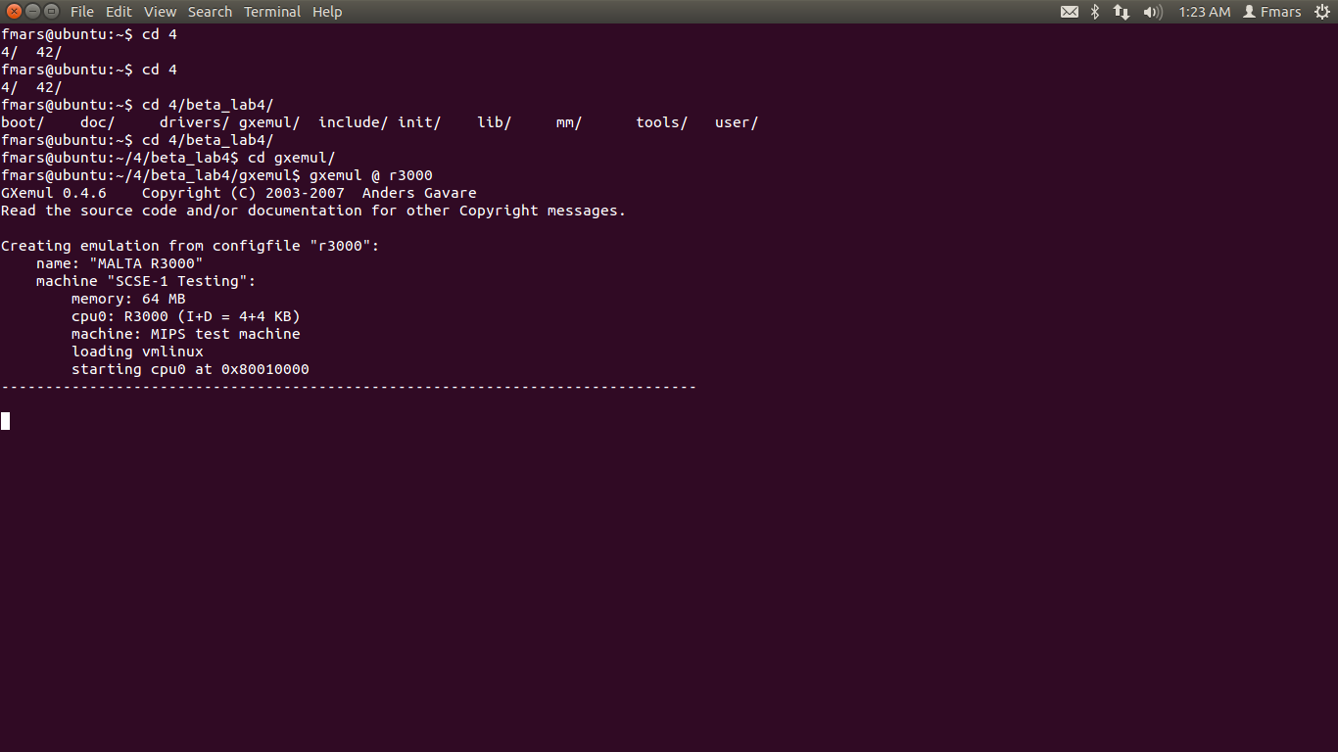
2.由此可以看出子进程已经开始运行，说明系统调用可以正常运行，而且fork函数正确
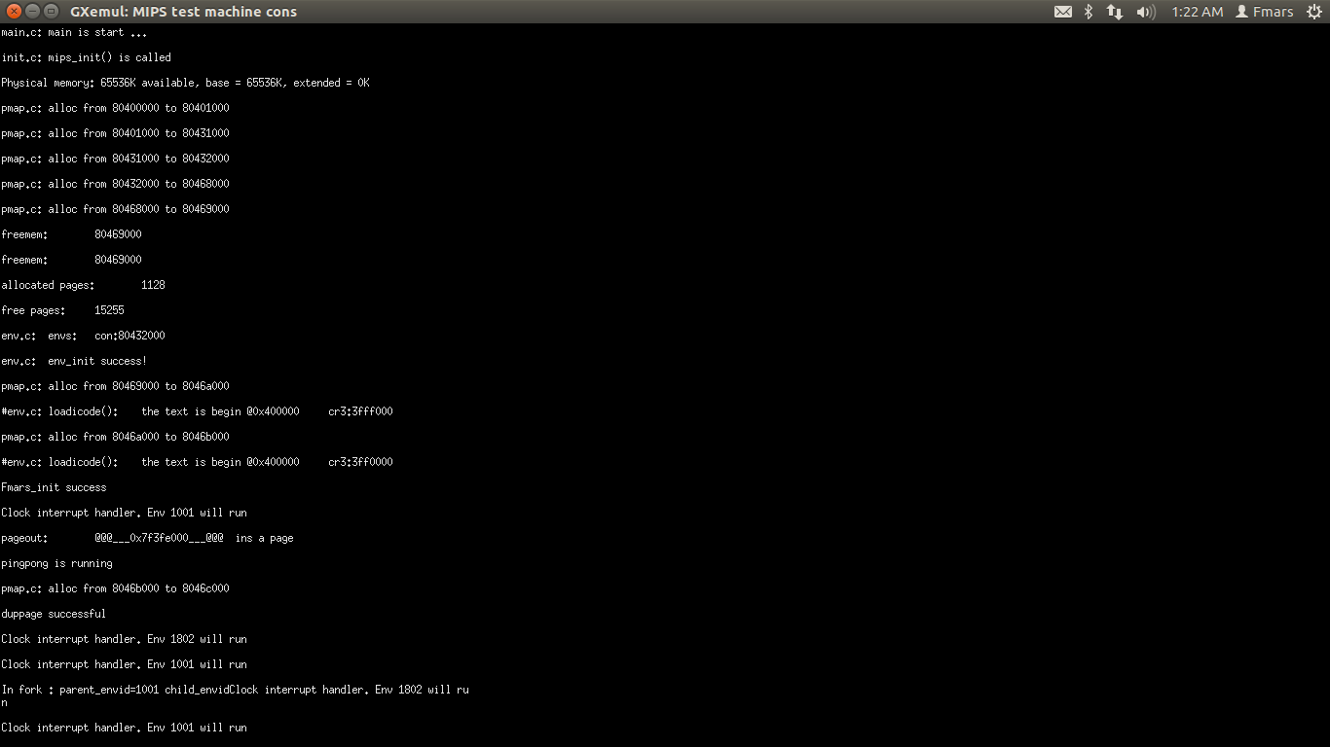
3. 由此可以看到两个进程已经可以相互通信
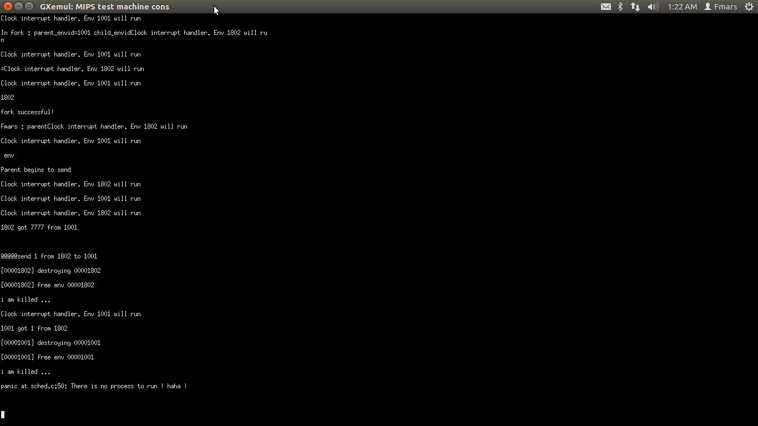

五．每个人的工作
姓名 | 完成的工作
冯嘉程 | 学习相关内容，阅读mit代码，完成编码
杨金礼 | 学习相关内容，共同完成编码
张晓雷 | 学习相关内容
丹增顿云 | 学习相关内容

六．会议记录
都第四次了，基本不会有什么开会讨论，你懂得。。

六、实验心得
这次作业花了相当长的时间啊，而且占用了助教多个宝贵的一晚上，这里一定要谢谢李康助教，如果没有他的帮助我肯定是无法完成这次试验的。
通过这次实验，确实学到了不少东西，原先以为很简单的东西实现起来发现还是有不少挑战。一开始的系统调用，搞明白了什么叫做由用户态陷入内核态，然后写fork的时候，才明白为什么一个函数能有两个返回值，很有趣。之后呢在做duppage时遇到了极大的问题，后来发现，一方面ELDK这个编译器确实有点小问题（看反汇编后才发现）在编译*P时有编译错误，然后实验给的运行库居然也是有问题的（print）,最后在李康助教的耐心帮助下终于完成了。最后写ipc内容，相对就容易多了，自己搞了搞也没用Mit的那套办法也高出了了，应该在用户态就可以完成。

